NGINX Docker Static Site
Run a static website inside a Docker container using NGINX.
Step 1: Create the Project Folder
This is where your Docker + NGINX static website project will live.
mkdir project
cd project
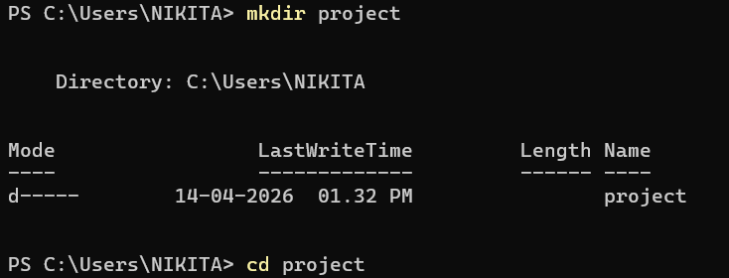
Step 2: Create index.html
Now we’ll create your simple static webpage.
1. Create the file
Inside your project folder, run:
touch index.html
2. Add content to index.html
Open the file in any editor (VS Code recommended) and paste this:
<!DOCTYPE html>
<html>
<head>
<title>My Docker Web App</title>
</head>
<body>
<h1>Hello from Docker + NGINX!</h1>
<p>This is my first static website running inside a Docker container.</p>
</body>
</html>
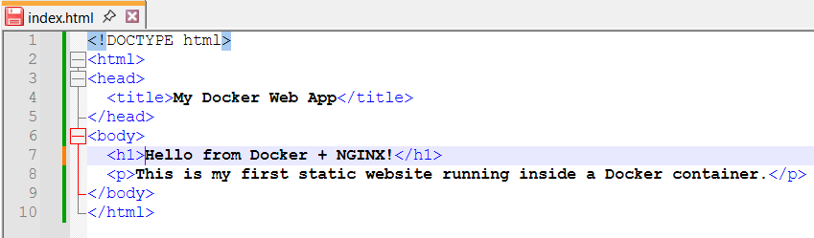

Step 3: Create Dockerfile
Now we will tell Docker how to run your website using NGINX.
1. Create Dockerfile
Go to your project folder and create a file named: Dockerfile
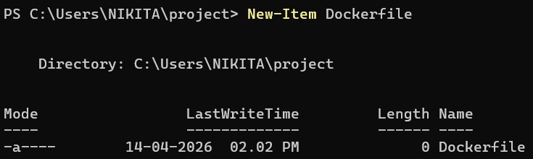
2. Open Dockerfile and paste this:
FROM nginx:alpine
COPY . /usr/share/nginx/html
EXPOSE 80
- FROM nginx:alpine → uses lightweight NGINX server
- COPY . → copies your website files into server
- EXPOSE 80 → opens port 80 for web access

Step 4: Build your Docker Image
1. Open Terminal in your project folder
Make sure you are inside:
C:\Users\NIKITA\project
You should see:
- Dockerfile
- index.html

2. Build the Docker image
Run this command:
docker build -t my-web-app .
- docker build → creates image
- -t my-web-app → names your image
- . → means current folder
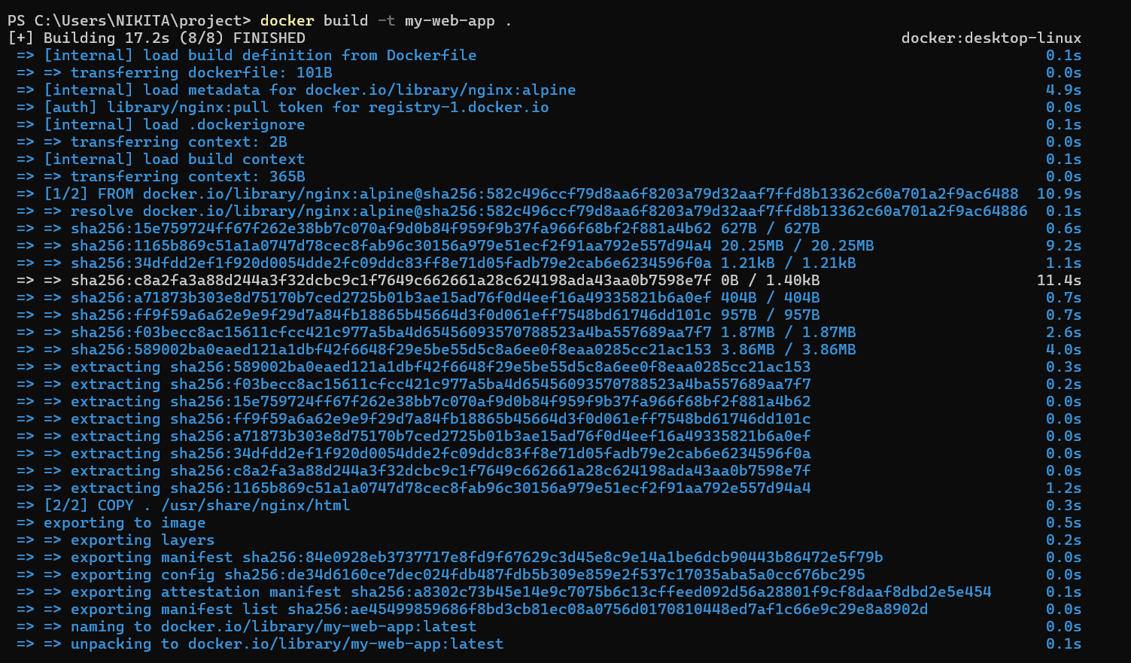

Step 5: Run Your Docker Container
Now we will start your website using NGINX inside a Docker container.

1. Run the container
In your terminal, run:
docker run -d -p 8081:80 my-web-app
- docker run → starts container
- -d → runs in background
- -p 8081:80 → connects your PC port 8081 to container port 80
- my-web-app → your image name
2. Open in browser
Now go to:
http://localhost:8081
Output:
You should see:
